Running a selenium project from Jenkins with the help of BAT file

1. Go to your selenium project and create a .txt file and add below command in the file.

java -cp ".\bin;.\lib\*" org.testng.TestNG testng.xml

2. saveas that .txt file as : "run.bat" (insert " " in file name while saving )

3. then we get run.bat file created  as below :

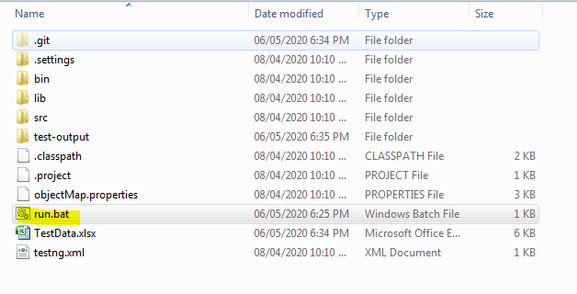

4. Now push that project to GIT and create a jenkins job for that repository and add below settings :

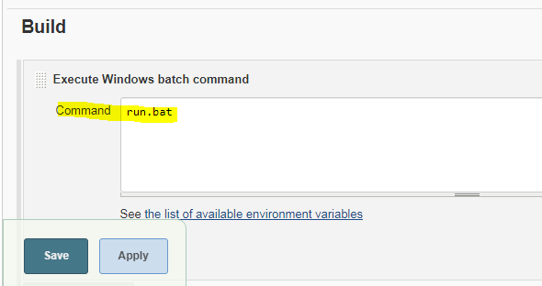

so now onwards the selenium project will be executed by running this bat file. (Instead of creating a bat file we can write this command in the above Command text box. : java -cp ".\bin;.\lib\*" org.testng.TestNG testng.xml. this also works in the same way. )

NOTE : we can click on this bat file in folder explorer to start the execution of our selenium project

On Wed, Apr 8, 2020 at 2:34 PM Pratik Toke <[pratik.toke07@gmail.com](mailto:pratik.toke07@gmail.com)> wrote:

VIMP :

look at console

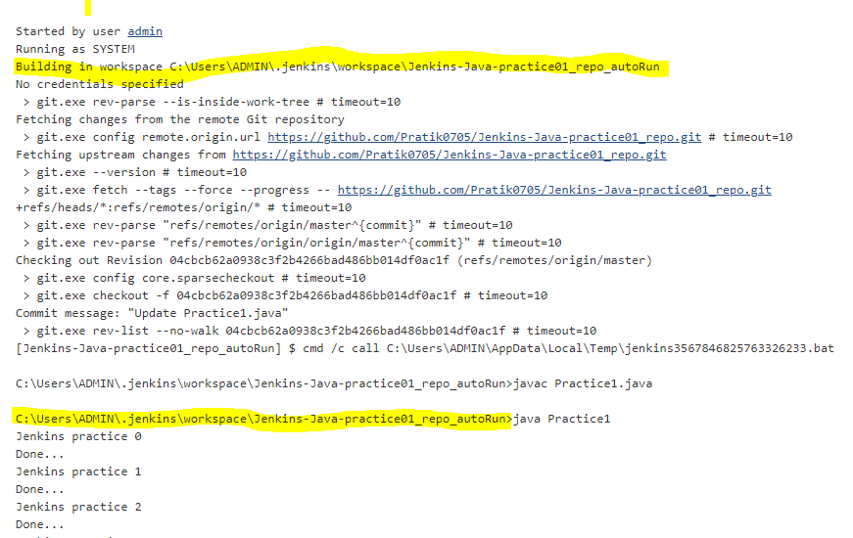

both the highlighted addresses should be same.  and in the config section > the command should be :

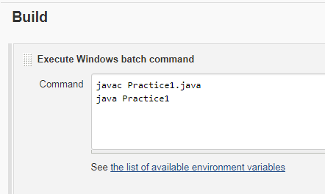

command to run testng from cmd :

java -cp  D:\SeleniumW\HybridFramework_jenkins_git\lib\*;D:\SeleniumW\HybridFramework_jenkins_git\bin org.testng.TestNG testng.xml

If we re in Project folder then we can give this command instead of the above command :

java -cp ".\bin;.\lib\*" org.testng.TestNG testng.xml   (IN JENKINS JOB USE THIS COMMAND)

Run testng.xml from jenkins :

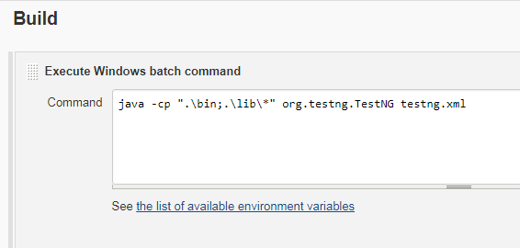

GitHub hook trigger for GITScm polling : With this option, we can instruct jenkins to build and execute a project whenever there is any change in GIT. I.e. if anyone push changes to GIT then the jenkins will run the build. This can be achieved by this option.

After selecting this option, go to the GitHub and open the repository > settings > webhooks > add webhook > add following details

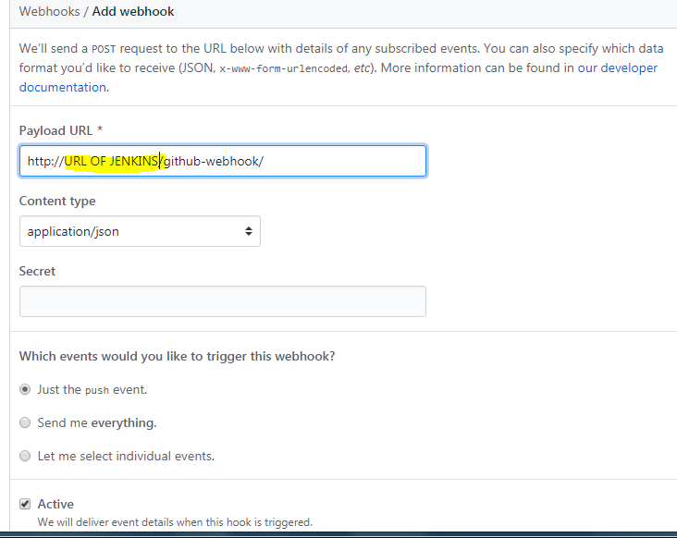

if we dont have jenkins url(i.e. we are running on localhost then use IP address as below)

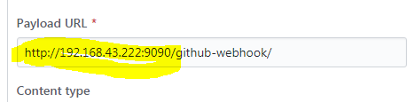

Now if there is any commit in the respective GIT repository then the build will be automatically triggered in Jenkins.

On Tue, Apr 7, 2020 at 12:29 PM Pratik Toke <[pratik.toke07@gmail.com](mailto:pratik.toke07@gmail.com)> wrote:

Jenkins is used for continuous delivery and continuous integration.

there are many developers work on a project at the same time and they push their code to Git or any other VCS. As soon as any developer push changes to the remote repository Jenkins take that latest code and trigger a build. If there is any problem / error / issue then immediately we will be notified by Jenkins.

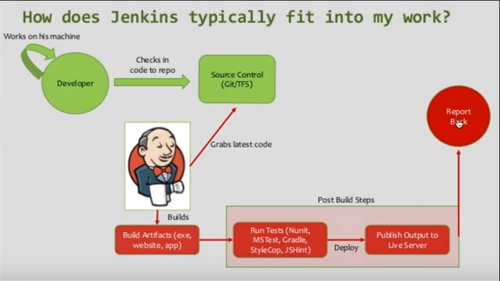

We can integrate unit test / some test cases that need to be executed after the successful build. Jenkins sends the report to us after this. This is called continuous integration. As soon as there is any change in code, the entire cycle begins.

To install jenkins, Download .war file fron jenkins website. then save that file to appropriate location in your machine, then go to that location and start a cmd there. Enter below command :

java -jar jenkins.war --httpPort=9090 (if we want to start Jenkins on default i.e. 8080 port then eliminate --httpPort=9090 from the command)

Let cmd show that Jenkins is up and running. then go to browser and enter a URL : <http://localhost:9090>

for the first time it will ask password, enter the password generated on cmd.

Every time to work on jenkins, we have to execute this command and then we have to hit the URL. default username is admin and the password is the one generated on cmd while installing at the first time.

We can create multiple projects and can create dependencies i.e. one will be executed after the build of another is successful.

**Configure Jenkins with GIT**

we can also run a java program written on a local machine with the help of jenkins. Ju st we need to execute it on our machine with the help of command line and we have to copy the command line steps to Build trigger > execute windows batch command.

To execute a java program periodically from my local machine :

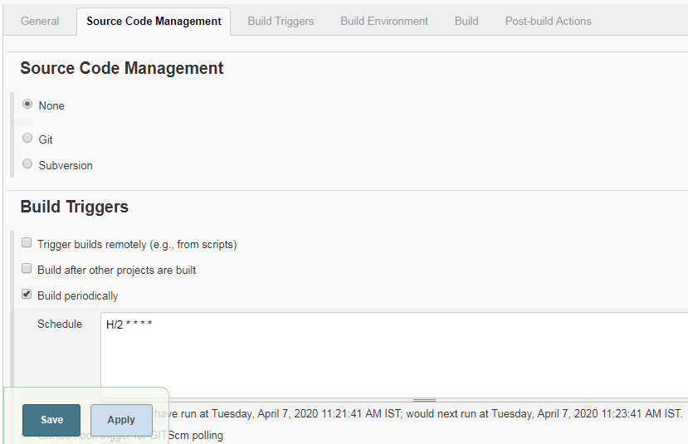

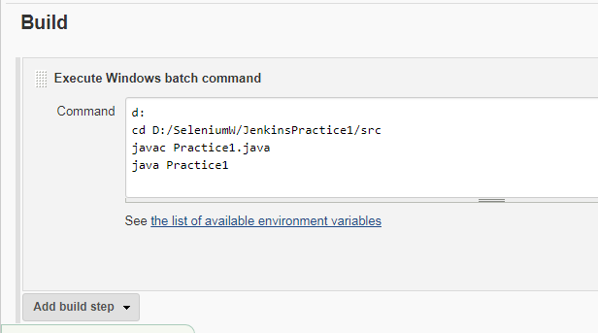

it will run the Practice1.java program from local machine as per the scheduled interval.

To Run a java program available on GIT with a scheduled interval :

Only add the below settings + all the settings shown in the above two screenshots

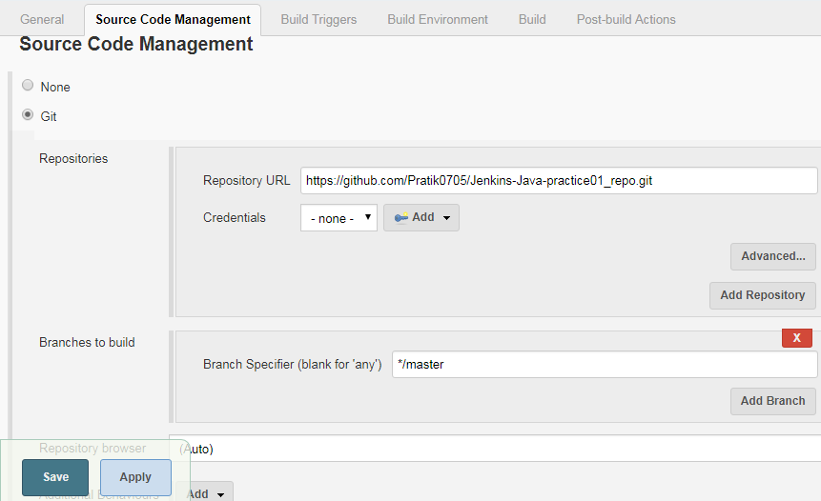

Run a build after any new changes are pushed to git (This is why actually GIT is mostly being used in organizations. To run build as soon as any developer adds code to GIT repo.)

Perform the below-mentioned changes in the above project. Keep rest everything as it is.

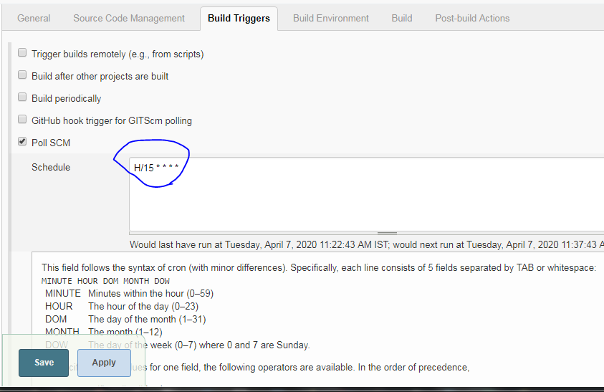

Because of the above settings, jenkins will check the GIT repository after every 15mins. if there is any code change in the repo then the build will be triggered.

Send email notifications :

Click on Manage Jenkins gear icon

click on Configure system

Go down and you will see a section : **E-mail Notification**

**for now using this account to send emails to other accounts via Jenkins :**[pratikjenkinstest@gmail.com](mailto:pratikjenkinstest@gmail.com)

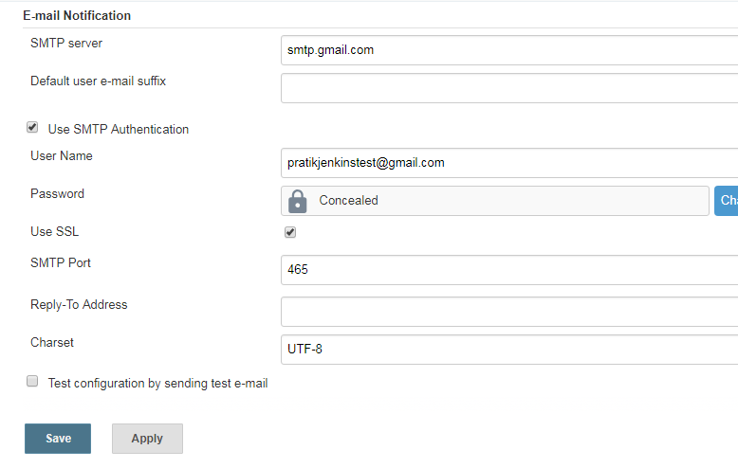

In a Jenkins job, here in this section, we can add email ID to get triggers after build.

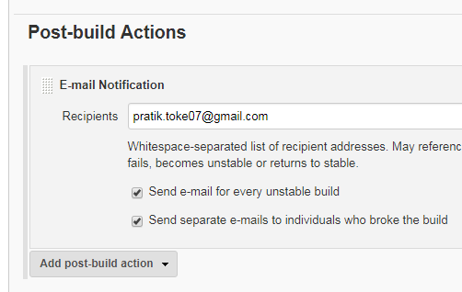

61f36bb37d684b2c8c657924345399ad

To learn more about Jenkins : [https://www.youtube.com/watch?v=89yWXXIOisk](https://eur02.safelinks.protection.outlook.com/?url=https%3A%2F%2Fwww.youtube.com%2Fwatch%3Fv%3D89yWXXIOisk&data=04%7C01%7Cpratik.toke%40fisglobal.com%7Cb91f04044dd746a3e16a08d97993bddf%7Ce3ff91d834c84b15a0b418910a6ac575%7C0%7C0%7C637674497726337779%7CUnknown%7CTWFpbGZsb3d8eyJWIjoiMC4wLjAwMDAiLCJQIjoiV2luMzIiLCJBTiI6Ik1haWwiLCJXVCI6Mn0%3D%7C1000&sdata=FYBvKs4SSIizd5im5mvA97qP9%2Fz%2FQX7VD2ACyDsrGU0%3D&reserved=0)